**1. E-commerce Order Management (Classes & Objects):Create a class Order with attributes orderID, customerName, and orderAmount.Implement methods to place an order, display order details, and apply a discount for orders above 5000.**

**package** SetA;

**import** java.util.Scanner;

**public** **class** Question1 {

Scanner sc=**new** Scanner(System.***in***);

**public** **int** orderID,itemNumber,qt;

**public** String orderName;

**public** **double** orderAmount,amount;

**public** **void** ItemDetails() {

System.***out***.println("List of Items:");System.***out***.println("1.Headphone 2.Earbuds 3.Mobile");}

**public** **void** placeOrder() {

System.***out***.println("Please enter item Number and Quantity");

itemNumber=sc.nextInt();qt=sc.nextInt();}

**public** **int** displayOrder() {

**switch**(itemNumber) {

**case** 1: System.***out***.println(Headphone );**break**;

**case** 2: System.***out***.println(Earbuds );**break**;

**case** 3: System.***out***.println(Mobile);**break**;}

**return** 0;}

**public** **double** orderAmount() {

**switch**(itemNumber) {

**case** 1:

amount=700*qt;**if**(amount>5000) {amount=amount-(amount*0.1);}**break**;

**case** 2:

amount=1000*qt;**if**(amount>5000) {amount=amount-(amount*0.12);}**break**;

**case** 3:

amount=10000*qt;**if**(amount>5000) {amount=amount-(amount*0.2);}**break**;}

**return** amount;

}

**public** **static** **void** main(String[] args) {

Question1 a=**new** Question1();a.ItemDetails();

a.placeOrder();

a.displayOrder();

System.***out***.println("Final Amount to be paid is: "+a.orderAmount());}}

Output:

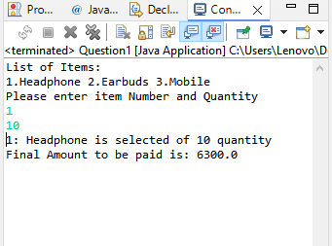

2. Ride-Sharing System (Polymorphism):

Define an interface Vehicle with a method calculateFare(distance).

Implement Car and Bike classes that calculate fare differently (e.g., Car: ₹10/km, Bike: ₹5/km).

Use polymorphism to calculate the fare based on user input.

**package** SetA;

**public** **interface** Vehical {

**void** calculateFare(**double** distance);}

**package** SetA;

**import** java.util.Scanner;

**class** Car **implements** Vehical {

**public** **void** calculateFare(**double** dist){

System.***out***.println("Fare: "+dist*10);}}

**class** Bike **implements** Vehical{

**public** **void** calculateFare(**double** dist){

System.***out***.println("Fare: "+dist*5);}}

**public** **class** Question2 {

**public** **static** **void** main(String[] args) {

Scanner sc=**new** Scanner(System.***in***);

System.***out***.println("please enter a number \n 1.Car 2.Bike");

**int** choice=sc.nextInt();

System.***out***.println("please enter distance");

**double** dist=sc.nextInt();

**if**(choice==1) {

Car c=**new** Car();

c.calculateFare(dist);}

**else** {

Bike b=**new** Bike();

b.calculateFare(dist);}}}

**Output:**

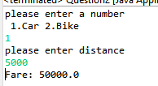 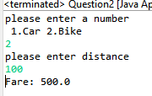

3.Smart Home Automation (Abstraction & Interfaces):

Create an abstract class Appliance with methods turnOn() and turnOff().

Implement subclasses Fan and Light, overriding the methods to display appropriate messages.

**package** SetA;

**public** **abstract** **class** Appliance {

**public** **abstract** **void** TurnOff();

**public** **abstract** **void** TurnOn();

}

**package** SetA;

**class** Fan **extends** Appliance{

**public** **void** TurnOff() {

System.***out***.println("Fan is off");}

**public** **void** TurnOn() {

System.***out***.println("Fan is on");}}

**class** Light **extends** Appliance{

**public** **void** TurnOff() {

System.***out***.println("Light is off");}

**public** **void** TurnOn() {

System.***out***.println("Light is on");}}

**public** **class** Question3 {

**public** **static** **void** main(String[] args) {

Light l=**new** Light();

Fan f=**new** Fan();

l.TurnOn();

l.TurnOff();

f.TurnOn();

f.TurnOff();

}}

**Output:**

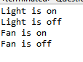

4.Bank Loan Eligibility Checker:

Ask the user for age, monthly income, and credit score.

Use conditions to determine loan eligibility:

Age < 21 → Not eligible

Income < ₹20,000 → Not eligible

Credit Score < 650 → Low-interest loan

Otherwise → Eligible for a standard loan

**package** SetA;

**import** java.util.Scanner;

**public** **class** Question4 {

**int** age;

**double** income;

**double** score,loan;

**void** LoanEligibility(**int** a, **double** i, **double** s){

**this**.age=a;

**this**.income=i;

**this**.score=s;

**if**(age<21) {

System.***out***.println("Not Elegible .....Age must be grater than 21");}

**else** **if**(income<20000) {

System.***out***.println("Not Elegible .....Income must be grater than 20000");}

**else** **if**(score<650) {

System.***out***.println("Elegible for low interest loan");}

**else** {

System.***out***.println("Elegible for standard interest loan");}}

**public** **static** **void** main(String[] args) {

Scanner sc=**new** Scanner(System.***in***);

Question4 a=**new** Question4();

System.***out***.println("Hello Welcome!");

System.***out***.println("Please enter age:");

**int** age=sc.nextInt();

System.***out***.println("Please enter Monthly income:");

**double** income=sc.nextDouble();

System.***out***.println("Please enter credit score:");

**double** cs=sc.nextDouble();

a.LoanEligibility(age,income,cs);}}

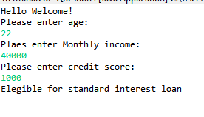 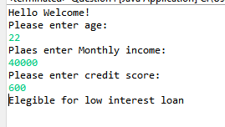

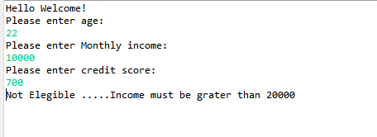 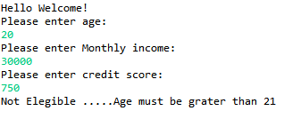

5.Online Shopping Cart System (Classes & Objects):

Create a class Product with attributes like productID, name, and price.

Create a class Cart that contains a list of products and methods to add items, remove items, and display the total bill.

**package** SetA;

**import** java.util.Arrays;

**import** java.util.Scanner;

**class** Product{

**public** **int** ProductId[]= {1,2,3};

**public** String ProductName[]= {"1.TV","2.Fridge","3.AC"};

**public** **double** ProductPrice[]= {6000,25750.79,25000};

@Override

**public** String toString() {

**return** "ProductId=" + Arrays.*toString*(ProductId) + "\nProductName=" + Arrays.*toString*(ProductName)

+ "\nProductPrice=" + Arrays.*toString*(ProductPrice) + "]";

}

}

//

**class** Cart **extends** Product{

Question5 q=**new** Question5();

**int** cartProductId[]=**new** **int**[5];

String cartProductName[]=**new** String[5];

**double** cartProductPrice[]=**new** **double**[5];

**void** addItem(**int** i){

cartProductId[0]=ProductId[i-1];

cartProductName[0]=ProductName[i-1];

cartProductPrice[0]=ProductPrice[i-1];

System.***out***.println("\nItem added in cart is:");

System.***out***.print(cartProductId[0]+"\t"+cartProductName[0]+"\t"+cartProductPrice[0]);

}

**void** removeItem(**int** i){

cartProductId[0]=0;

cartProductName[0]=**null**;

cartProductPrice[0]=0;

System.***out***.println("\nItem deleted from cart is:");

System.***out***.print(cartProductId[0]+"\t"+cartProductName[0]+"\t"+cartProductPrice[0]);

}

**void** dispalyTotalbill(){

**double** totalamt=0;

totalamt=totalamt+cartProductPrice[0];

System.***out***.println("\nTotalPayable amount is: "+totalamt);

}

}

//

**public** **class** Question5{

**public** **int** totalItems;

**public** **static** **void** main(String[] args) {

Product p=**new** Product();

Cart c=**new** Cart();

Question5 q=**new** Question5();

Scanner sc=**new** Scanner(System.***in***);

System.***out***.println(p);

System.***out***.println();

// System.out.println("Enter total items want to add");

// q.totalItems=sc.nextInt();

c.addItem(2);

c.removeItem(1);

c.addItem(3);

c.dispalyTotalbill();

}

}

Output:

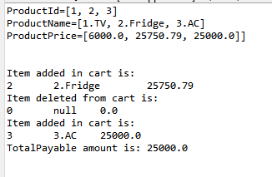

6.Car Rental System (Interface Implementation):

Define an interface RentalService with a method calculateRentalPrice(int days).

Implement two classes CarRental and BikeRental with different rental rates per day.

Use polymorphism to calculate rental prices dynamically based on user input.

**package** SetA;

**public** **interface** RentalService {

**void** calculateRentalPrice(**int** days);

}

**package** SetA;

**class** BikeRental **implements** RentalService{

**public** **void** calculateRentalPrice(**int** days){

System.***out***.println("Bike rentcharges per day are: 100/-");

System.***out***.println("Hence total charges: "+days*100+" for "+days+" days");

}

}

**class** CarRental **implements** RentalService{

**public** **void** calculateRentalPrice(**int** days){

System.***out***.println("Car rentcharges per day are: 500/-");

System.***out***.println("Hence total charges: "+days*500+" for "+days+" days");

}

}

**public** **class** Question6 {

**public** **static** **void** main(String[] args) {

CarRental c=**new** CarRental();

BikeRental b=**new** BikeRental();

c.calculateRentalPrice(20);

System.***out***.println();

b.calculateRentalPrice(10);

}

}

Output:

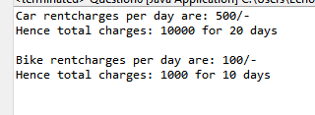

1. Age Verification for Driving License

Ask the user to enter their age.

If the age is less than 18, throw an InvalidAgeException.

Display "You must be 18 or older to apply for a driving license"

**package** SetA;

**public** **class** InvalidAgeException **extends** Exception{

InvalidAgeException(String e){

**super**(e);

}

}

**package** SetA;

**import** java.util.Scanner;

**public** **class** Question7 {

**public** **static** **void** main(String[] args) {

Scanner sc=**new** Scanner(System.***in***);

System.***out***.println("Age Verification for Driving License");

System.***out***.println("Enter Age");

**int** age=sc.nextInt();

**try** {

**if**(age<18) {

**throw** **new** InvalidAgeException("You must be 18 or older to apply for a driving license");

}

**else** {

System.***out***.println("Eligible");

}

}

**catch**(InvalidAgeException e) {

System.***out***.println(e.getMessage());

}

}

}

Output:

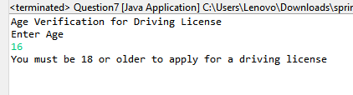

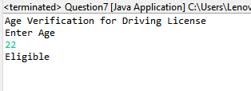

8. Division Calculator (Handling Divide by Zero)

Write a program that asks for two numbers and performs division.

If the denominator is zero, handle ArithmeticException and display "Division by zero is not allowed".

**package** SetA;

**public** **class** CustomArithmaticException **extends** ArithmeticException{

**public** CustomArithmaticException(String e){**super**(e);}

**public** String getLocalizedMessage() {

**return** **super**.getMessage();}}

**package** SetA;

**import** java.util.Scanner;

**public** **class** Question8 {

**public** **static** **void** main(String[] args) {

Scanner sc=**new** Scanner(System.***in***);

**try** {

System.***out***.println("Enter 2 numbers to perform division");

**int** a=sc.nextInt();

**int** b=sc.nextInt();

**if**(b==0) {

**throw** **new** CustomArithmaticException("Division by zero is not allowed");

}

System.***out***.println("a/b: "+a/b);

}

**catch**(ArithmeticException e) {

// System.out.println(e.getMessage());

System.***out***.println(e.getLocalizedMessage());}

}}

Output:

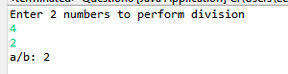

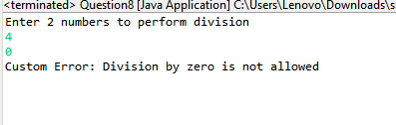

9.Online Shopping - Product Availability

Create an array of 5 products (["Laptop", "Phone", "Tablet", "Watch", "Headphones"]).

Ask the user for a product index (0-4).

If the user enters an invalid index, handle ArrayIndexOutOfBoundsException and display "Product not found".

**package** SetA;

**import** java.util.Scanner;

**public** **class** Question9 {

**public** **static** **void** main(String[] args) {

Scanner sc=**new** Scanner(System.***in***);

String products[]= {"0.Laptop", "1.Phone", "2.Tablet", "3.Watch", "4.Headphones"};

System.***out***.println("Enter a index number:");

**try** {

**int** a=sc.nextInt();

**if**(a<0 || a>4) {

**throw** **new** ArrayIndexOutOfBoundsException("Product not available");

}

System.***out***.println(products[a]+" is selected");

}

**catch**(ArrayIndexOutOfBoundsException e) {

System.***out***.println(e.getMessage());

}

}

}

Output:

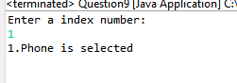



10.Invalid Bank Account Number

Ask the user to enter a 6-digit bank account number.

If the entered number has less/more than 6 digits, throw a InvalidAccountNumberException.Display "Please enter a valid 6-digit account number".

**package** SetA;

**public** **class** InvalidAccountNumberException **extends** Exception{

InvalidAccountNumberException(String e){

**super**(e);

}

}

**package** SetA;

**import** java.util.Scanner;

**public** **class** Question10 {

**public** **static** **void** main(String[] args) {

Scanner sc=**new** Scanner(System.***in***);

**int** length=0;

System.***out***.println("Enter 6 digit account number:");

**int** acc=sc.nextInt();

**while**(acc!=0) {

length++;

acc=acc/10;

}

**try** {

**if**(length<6 || length>6){

**throw** **new** InvalidAccountNumberException("Please enter a valid 6-digit account number");

}

System.***out***.println("Valid account Number");

}

**catch**(InvalidAccountNumberException e) {

System.***out***.println(e.getMessage());

}

}

}

**Output:**

